CMOS 4-Bit Full Adder with Parallel Carry Out

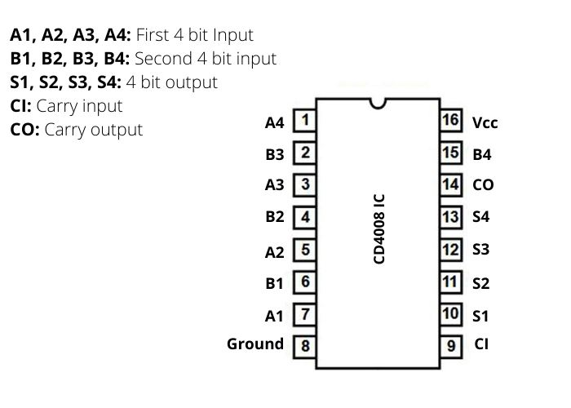

Code Pascal:-

